**Case Study - Foodie-Fi**

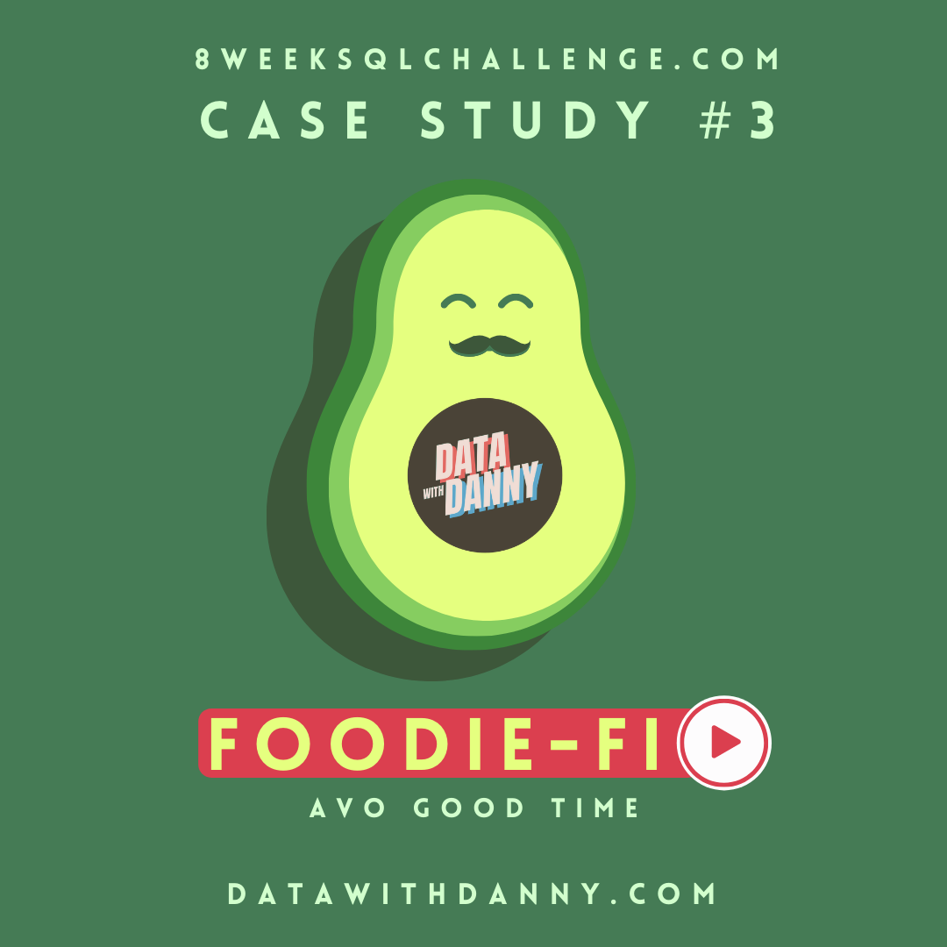

**Introduction**

**Subscription based businesses are super popular and Danny realised that there was a large gap in the market - he wanted to create a new streaming service that only had food related content - something like Netflix but with only cooking shows!**

**Danny finds a few smart friends to launch his new startup Foodie-Fi in 2020 and started selling monthly and annual subscriptions, giving their customers unlimited on-demand access to exclusive food videos from around the world!**

**Danny created Foodie-Fi with a data driven mindset and wanted to ensure all future investment decisions and new features were decided using data. This case study focuses on using subscription style digital data to answer important business questions.**

**Available Data**

**Danny has shared the data design for Foodie-Fi and also short descriptions on each of the database tables - our case study focuses on only 2 tables but there will be a challenge to create a new table for the Foodie-Fi team.**

**All datasets exist within the foodie_fi database schema - be sure to include this reference within your SQL scripts as you start exploring the data and answering the case study questions**.

**Entity Relationship Diagram**

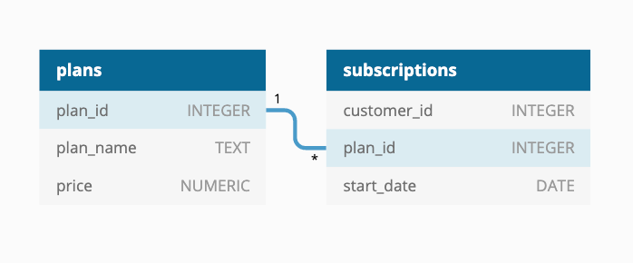

**Table 1: plans**

**Customers can choose which plans to join Foodie-Fi when they first sign up.**

**Basic plan customers have limited access and can only stream their videos and is only available monthly at $9.90**

**Pro plan customers have no watch time limits and are able to download videos for offline viewing. Pro plans start at $19.90 a month or $199 for an annual subscription.**

**Customers can sign up to an initial 7 day free trial will automatically continue with the pro monthly subscription plan unless they cancel, downgrade to basic or upgrade to an annual pro plan at any point during the trial.**

**When customers cancel their Foodie-Fi service - they will have a churn plan record with a null price but their plan will continue until the end of the billing period.**

| **plan_id** | **plan_name** | **price** |
| --- | --- | --- |
| 0 | trial | 0 |
| 1 | basic monthly | 9.90 |
| 2 | pro monthly | 19.90 |
| 3 | pro annual | 199 |
| 4 | churn | null |

**Table 2: subscriptions**

**Customer subscriptions show the exact date where their specific plan_id starts.**

**If customers downgrade from a pro plan or cancel their subscription - the higher plan will remain in place until the period is over - the start_date in the subscriptions table will reflect the date that the actual plan changes.**

**When customers upgrade their account from a basic plan to a pro or annual pro plan - the higher plan will take effect straightaway.**

**When customers churn - they will keep their access until the end of their current billing period but the start_date will be technically the day they decided to cancel their service.**

| **customer_id** | **plan_id** | **start_date** |
| --- | --- | --- |
| 1 | 0 | 2020-08-01 |
| 1 | 1 | 2020-08-08 |
| 2 | 0 | 2020-09-20 |
| 2 | 3 | 2020-09-27 |
| 11 | 0 | 2020-11-19 |
| 11 | 4 | 2020-11-26 |
| 13 | 0 | 2020-12-15 |
| 13 | 1 | 2020-12-22 |
| 13 | 2 | 2021-03-29 |
| 15 | 0 | 2020-03-17 |
| 15 | 2 | 2020-03-24 |
| 15 | 4 | 2020-04-29 |
| 16 | 0 | 2020-05-31 |
| 16 | 1 | 2020-06-07 |
| 16 | 3 | 2020-10-21 |
| 18 | 0 | 2020-07-06 |
| 18 | 2 | 2020-07-13 |
| 19 | 0 | 2020-06-22 |
| 19 | 2 | 2020-06-29 |
| 19 | 3 | 2020-08-29 |

**Interactive SQL Instance**

**You can use the embedded DB Fiddle below to easily access these example datasets - this interactive session has everything you need to start solving these questions using SQL.**

**You can click on the Edit on DB Fiddle link on the top right hand corner of the embedded session below and it will take you to a fully functional SQL editor where you can write your own queries to analyse the data.**

**You can feel free to choose any SQL dialect you’d like to use, the existing Fiddle is using PostgreSQL 13 as default.**

**Serious SQL students will have access to the same relevant schema SQL and example solutions which they can use with their Docker setup from within the course player!**

**Case Study Questions**

**This case study is split into an initial data understanding question before diving straight into data analysis questions before finishing with 1 single extension challenge.**

1. **Customer Journey**

Based off the 8 sample customers provided in the sample from the subscriptions table, write a brief description about each customer’s onboarding journey.

Try to keep it as short as possible - you may also want to run some sort of join to make your explanations a bit easier!

**A complete result of the customer journey**

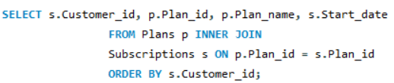

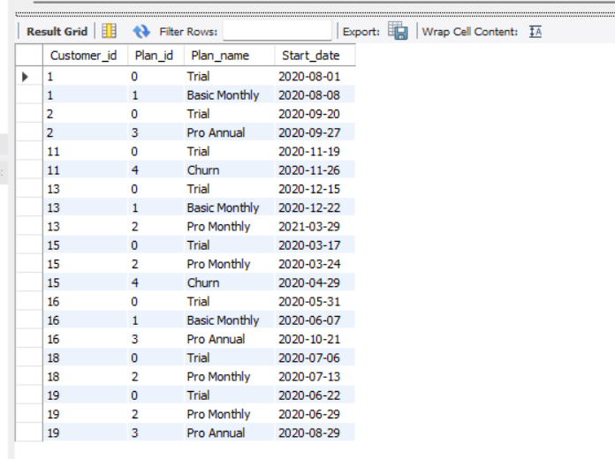

**Customer 1**

**Started on trial on Aug 1st, 2020, and after the 7 days of trial downgraded it to basic monthly.**

**Customer 2**

**Started on trial on Sep 20th, 2020, and after the 7 days of trial upgraded to pro annual.**

**Customer 11**

**Started on trial on Nov 19th, 2020, and after the 7 days of trial cancelled the plan (so sad! Foodie-fi is a great platform, come back my friend!)**

**Customer 13**

**Started on trial on Dec 15th, 2020, and after the 7 days of trial downgrade to basic monthly. In the next year, on Mar 29th, 2021 the customer plan was upgraded to pro monthly.**

**Customer 15**

**Started on trial on Mar 17th, 2020, and after the 7 days of trial it automatically continued to pro monthly plan until he cancels it in Apr 29th, 2020.**

**Customer 16**

**Started on trial on May 31st, 2020, and after the 7 days of trial downgraded to basic monthly, later in that year, the customer upgraded the plan to pro annual*.***

**Customer 18**

**Started on trial on Jul 06th, 2020, and after the 7 days of trial it automatically continued to pr**o **monthly.**

**Customer 19**

**Started on trial on Jun 22nd, 2020, and after the 7 days of trial it automatically continued to pro monthly until later that year the customer upgraded the plan to pro annual.**

1. **Data Analysis Questions**
2. How many customers has Foodie-Fi ever had?

SELECT COUNT(DISTINCT customer_id) count from Subscriptions;

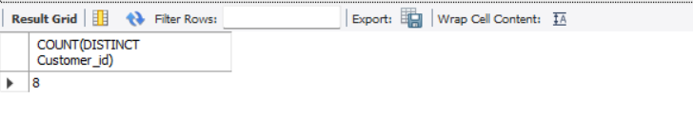

1. What is the monthly distribution of trial plan start_date values for our dataset - use the start of the month as the group by value

SELECT MONTHNAME(Start_date) Month, COUNT(Customer_id) Distributions

FROM Subscriptions WHERE Plan_id = 0

GROUP BY MONTH(Start_date)

ORDER BY MONTH(Start_date);

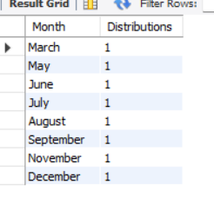

1. What plan start_date values occur after the year 2020 for our dataset? Show the breakdown by count of events for each plan name

SELECT p.Plan_id, p.Plan_name, COUNT(*) No_of_events

FROM Plans p

INNER JOIN Subscriptions s

ON p.plan_id = s.plan_id

WHERE YEAR(s.Start_date)> 2020

GROUP BY p.Plan_Name;

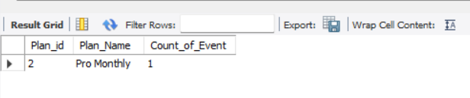

1. What is the customer count and percentage of customers who have churned rounded to 1 decimal place?

SELECT COUNT(*) Churned_customers,

ROUND((COUNT(*)/ (SELECT COUNT(DISTINCT customer_id) FROM Subscriptions)) * 100 ,1)

as percentage_of_customers

FROM Subscriptions

WHERE plan_id = 2 ;



1. How many customers have churned straight after their initial free trial - what percentage is this rounded to the nearest whole number?

CREATE VIEW ranking AS

SELECT

s.customer_id,

s.plan_id,

p.Plan_name,

-- Run a Row_Number() to rank plans from 0 to 4

ROW_NUMBER() OVER (

PARTITION BY s.customer_id

ORDER BY s.Plan_id) plan_rank

FROM Subscriptions s

INNER JOIN Plans p

ON s.plan_id = p.Plan_id;

select * from ranking;

SELECT

COUNT(*) AS churn_count,

ROUND(100 * COUNT(*) / (

SELECT COUNT(DISTINCT customer_id)

FROM foodie_fi.subscriptions),0) AS churn_percentage

FROM ranking

WHERE plan_id = 4

AND plan_rank = 2;

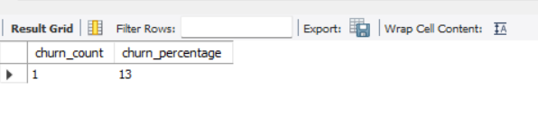

1. What is the number and percentage of customer plans after their initial free trial?

WITH next_plan_cte AS (

SELECT

customer_id,

plan_id,

LEAD(plan_id, 1) OVER( -- Offset by 1 to retrieve the immediate row's value below

PARTITION BY customer_id

ORDER BY plan_id) next_plan

FROM subscriptions)

SELECT

next_plan,

COUNT(*) conversions,

ROUND(COUNT(*)*100 / (SELECT COUNT(DISTINCT customer_id)

FROM Subscriptions),0) conversion_percentage

FROM next_plan_cte

WHERE next_plan IS NOT NULL

AND plan_id = 0

GROUP BY next_plan

ORDER BY next_plan;

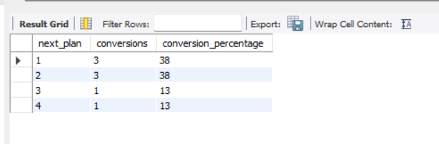

1. What is the customer count and percentage breakdown of all 5 plan_name values at 2020-12-31?

WITH next_plan AS(

SELECT

customer_id,

plan_id,

start_date,

LEAD(start_date, 1) OVER(PARTITION BY customer_id ORDER BY start_date) as next_date

FROM

subscriptions

WHERE

start_date <= '2020-12-31'),

-- Find customer breakdown with existing plans on or after 31 Dec 2020

customer_breakdown AS (

SELECT

plan_id,

COUNT(DISTINCT customer_id) AS customers

FROM

next_plan

WHERE

(next_date IS NOT NULL AND (start_date < '2020-12-31'

AND

next_date > '2020-12-31'))

OR

(next_date IS NULL AND start_date < '2020-12-31')

GROUP BY

plan_id)

SELECT

plan_id, customers,

ROUND(100 * customers / (

SELECT

COUNT(DISTINCT customer_id)

FROM

foodie_fi.subscriptions),1) AS percentage

FROM

customer_breakdown

GROUP BY

plan_id, customers

ORDER BY

plan_id;

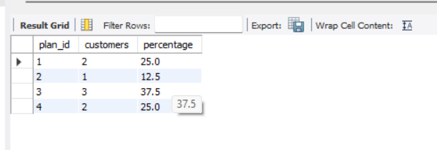

1. How many customers have upgraded to an annual plan in 2020?

SELECT

COUNT(DISTINCT customer_id) AS unique_customer

FROM

Subscriptions

WHERE

plan_id = 3

AND

start_date <= '2020-12-31';

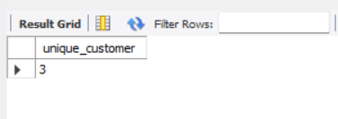

1. How many days on average does it take for a customer to an annual plan from the day they join Foodie-Fi?

WITH trial_plan AS

(SELECT

customer_id,

start_date trial_date

FROM

subscriptions

WHERE

plan_id = 0

),

-- Filter results to customers at pro annual plan = 3

annual_plan AS

(SELECT

customer_id,

start_date AS annual_date

FROM

subscriptions

WHERE

plan_id = 3

)

SELECT

ROUND(AVG(annual_date - trial_date),0) avg_days_to_upgrade

FROM

trial_plan tp

JOIN

annual_plan ap

ON

tp.customer_id = ap.customer_id;

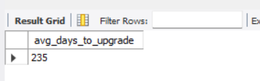

1. Can you further breakdown this average value into 30 day periods (i.e. 0-30 days, 31-60 days etc)

use foodie_fi;

WITH trial_plan AS

(

SELECT

customer_id,

start_date AS trial_date

FROM

subscriptions

WHERE

plan_id = 0

),

-- Filter results to customers at pro annual plan = 3

annual_plan AS

(SELECT

customer_id,

start_date AS annual_date

FROM

subscriptions

WHERE

plan_id = 3

),

time_lapse_tb as (

SELECT

tp.customer_id,

tp.trial_date,

ap.annual_date,

DATEDIFF(ap.annual_date,tp.trial_date) as diff

FROM

trial_plan tp

LEFT JOIN

annual_plan ap

ON

tp.customer_id = ap.customer_id

WHERE

annual_date IS NOT NULL

),

bins AS (

SELECT *,

FLOOR(diff/30) AS bins

FROM time_lapse_tb)

SELECT

CONCAT((bins*30)+1,'-',(bins+1)*30,'days') AS Days,

COUNT(diff) AS Total

FROM

bins

GROUP BY

bins;

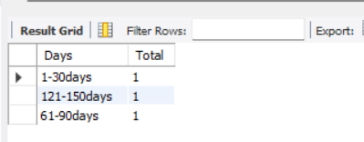

1. How many customers downgraded from a pro monthly to a basic monthly plan in 2020?

WITH next_plan_cte AS (

SELECT

customer_id,

plan_id,

start_date,

LEAD(plan_id, 1)

OVER(PARTITION BY customer_id

ORDER BY plan_id) next_plan

FROM subscriptions)

SELECT

COUNT(*) AS downgraded

FROM

next_plan_cte

WHERE

start_date <= '2020-12-31'

AND

plan_id = 2

AND

next_plan = 1;

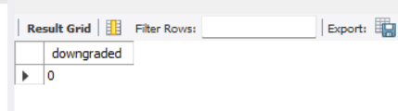

**C. Challenge Payment Question**

The Foodie-Fi team wants you to create a new payments table for the year 2020 that includes amounts paid by each customer in the subscriptions table with the following requirements:

* monthly payments always occur on the same day of month as the original start_date of any monthly paid plan
* upgrades from basic to monthly or pro plans are reduced by the current paid amount in that month and start immediately
* upgrades from pro monthly to pro annual are paid at the end of the current billing period and also starts at the end of the month period
* once a customer churns they will no longer make payments

Example outputs for this table might look like the following:

| **customer** | **plan_id** | **plan_name** | **payment_date** | **amount** | **payment_order** |
| --- | --- | --- | --- | --- | --- |
| 1 | 1 | basic monthly | 2020-08-08 | 9.90 | 1 |
| 1 | 1 | basic monthly | 2020-09-08 | 9.90 | 2 |
| 1 | 1 | basic monthly | 2020-10-08 | 9.90 | 3 |
| 1 | 1 | basic monthly | 2020-11-08 | 9.90 | 4 |
| 1 | 1 | basic monthly | 2020-12-08 | 9.90 | 5 |
| 2 | 3 | pro annual | 2020-09-27 | 199.00 | 1 |
| 13 | 1 | basic monthly | 2020-12-22 | 9.90 | 1 |
| 15 | 2 | pro monthly | 2020-03-24 | 19.90 | 1 |
| 15 | 2 | pro monthly | 2020-04-24 | 19.90 | 2 |
| 16 | 1 | basic monthly | 2020-06-07 | 9.90 | 1 |
| 16 | 1 | basic monthly | 2020-07-07 | 9.90 | 2 |
| 16 | 1 | basic monthly | 2020-08-07 | 9.90 | 3 |
| 16 | 1 | basic monthly | 2020-09-07 | 9.90 | 4 |
| 16 | 1 | basic monthly | 2020-10-07 | 9.90 | 5 |
| 16 | 3 | pro annual | 2020-10-21 | 189.10 | 6 |
| 18 | 2 | pro monthly | 2020-07-13 | 19.90 | 1 |
| 18 | 2 | pro monthly | 2020-08-13 | 19.90 | 2 |
| 18 | 2 | pro monthly | 2020-09-13 | 19.90 | 3 |
| 18 | 2 | pro monthly | 2020-10-13 | 19.90 | 4 |
| 18 | 2 | pro monthly | 2020-11-13 | 19.90 | 5 |
| 18 | 2 | pro monthly | 2020-12-13 | 19.90 | 6 |
| 19 | 2 | pro monthly | 2020-06-29 | 19.90 | 1 |
| 19 | 2 | pro monthly | 2020-07-29 | 19.90 | 2 |
| 19 | 3 | pro annual | 2020-08-29 | 199.00 | 3 |

**Payments Table Output**

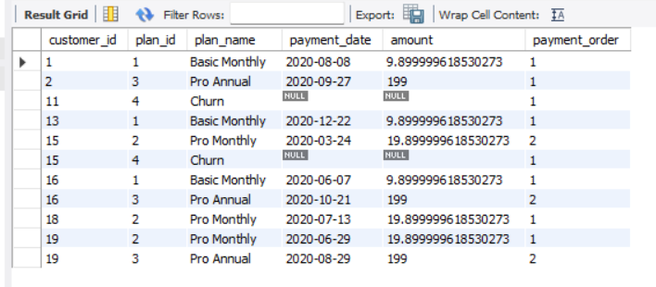

**D. Outside The Box Questions**

**The following are open ended questions which might be asked during a technical interview for this case study - there are no right or wrong answers, but answers that make sense from both a technical and a business perspective make an amazing impression!**

1. How would you calculate the rate of growth for Foodie-Fi?

**Metrics of growth for Foodie-Fi could work exploring customer and financial results. For customer growth, I would like to see**

**(New Total – Old Total)/Old Total. for churns and new signatures. And for financial results, it would be great to see the total income and profit compared to last period analyzed, and also break those numbers through type of signature.**

1. What key metrics would you recommend Foodie-Fi management to track over time to assess performance of their overall business?

* **Revenue (total and per membership)**
* **Profit**
* **Gross Margin**
* **Retention Rate**
* **CAC**
* **Employee Satisfaction**

1. What are some key customer journeys or experiences that you would analyze further to improve customer retention?

**I would focus on checking what is the most common path that lead a customer to churn, and try to understand (with surveys or somethings like that) why the customer decided that. Also, it would be great to check the most common path when customers do an upgrade, to try to reflect the good experience to the other ones that keep the basic plan.**

1. If the Foodie-Fi team were to create an exit survey shown to customers who wish to cancel their subscription, what questions would you include in the survey?

* **How often the customer used the service**
* **How long the customer was with Foodie-Fi**
* **Reason for leaving (unattractive contents, price, technical problems, found a better service, other[specify])**
* **Feedback (short text)**

1. What business levers could the Foodie-Fi team use to reduce the customer churn rate? How would you validate the effectiveness of your ideas?

* **Engage the customers: Bring them to inside the company, show them the company value. We could measure it with sentiment analysis with data from social networks and determine a target percentage of positive sentiment regard our content.**
* **Solve problems presented by customers: Customers complain a lot when a service/product is awful. So let's hear them and reduce the number of complains to the minimum possible.**
* **Give attention to the most valuable customers: the loyal customers should feel they're special. Let's represent them. We can measure effectiveness considering positive sentiment and maybe implement a indication program, and measure how that number grows.**
* **Have a retention plan to those who are leaving: If we offer something different in price or content, would they stay? (test with some and measure the number or retentions**)

**Observation**

**In this schema, we have 8 customers. Out of the 8 customers, there is 25% churn rate means 2 customers chooses churn and out of these 8 customers, only 3 customers upgraded to pro monthly plan.**

**Here by observing the stats the organization should focus on the customers who are churning the plans and then should focus on the customers who are taking monthly plans but not annual plans. They should take feedback from the customers and review them and improve their facilities according to customer’s feedback provided so that they can gain more subscribers and also to push the customers to take up pro annual plan.**

**Conclusion**

**This case study should reflect realistic questions we usually focus on for all product related analytics requests in a wide variety of industries, especially in the digital space!**

**---------------THANK YOU---------------**